- RESOLUTION, NEXT VISIT DATE & TIME as well as NEXT STEPS did not update in OUTCOME HISTORY when UPDATING & PENDING.
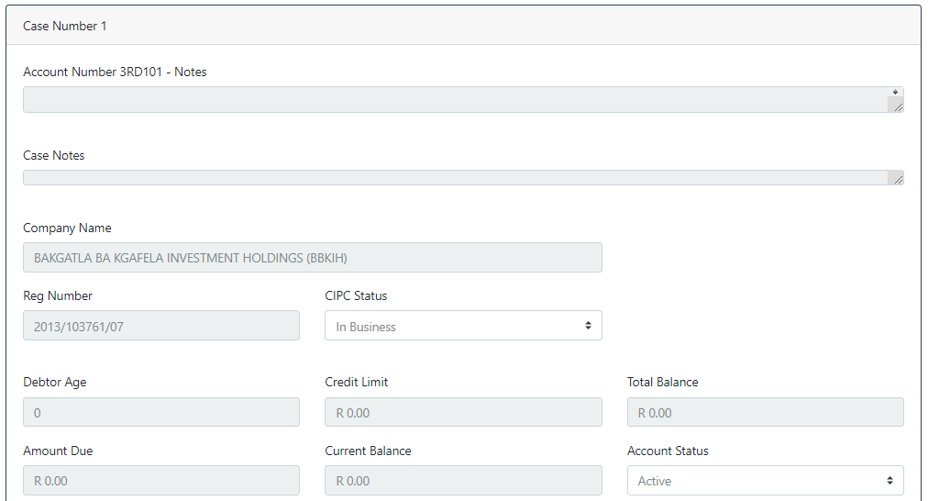

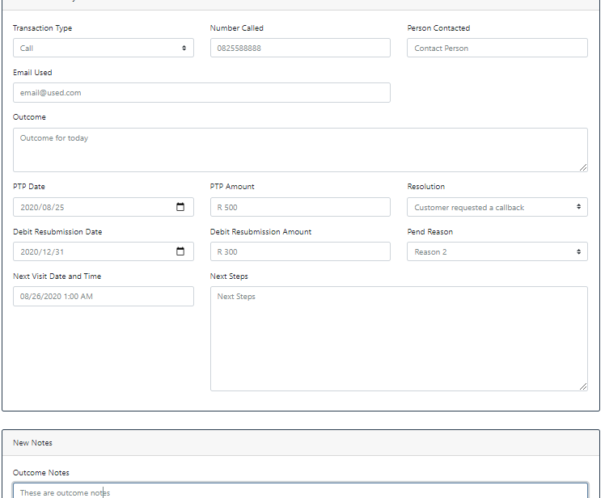

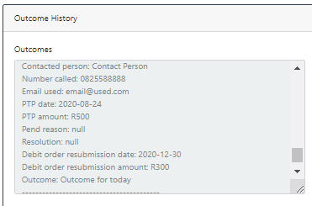
2.Mandatory fields:
- If Transaction Type is EMAIL then EMAIL ADDRESS must be mandatory.
- If Transaction Type is CALL then NUMBER CALLED must be mandatory.
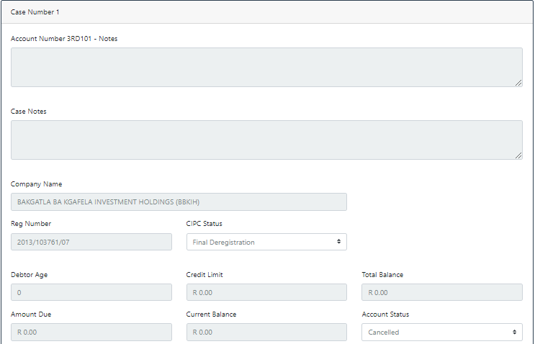

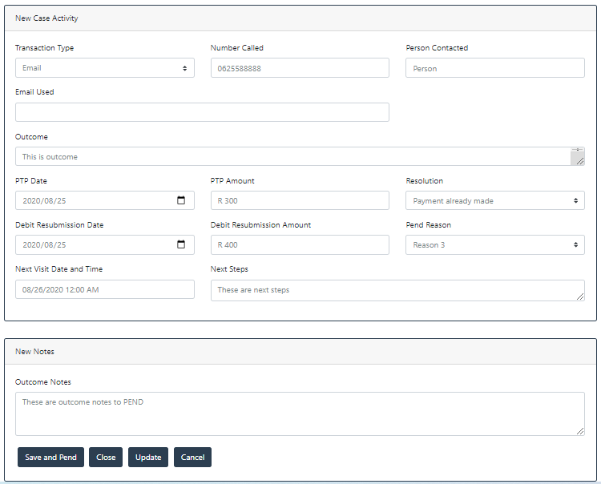

- Please sort OUTCOMES & OUTCOMES NOTES to show most recent entries first.

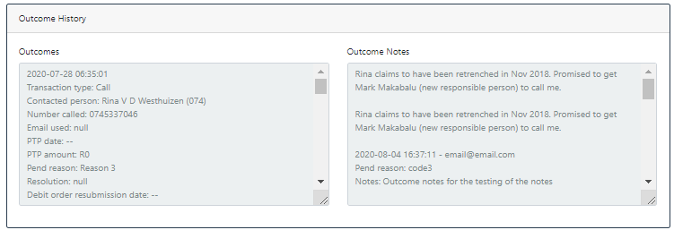

- Weird.. The CLOSE option updated the RESOLUTION in outcomes for all earlier entries…

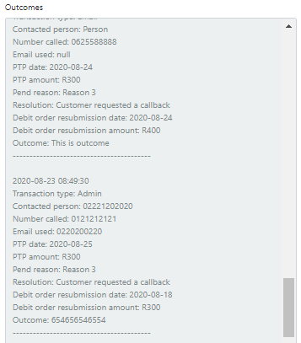

- Closed this one twice and it keeps ending up as OPEN even though it was Pended before I CLOSED it.
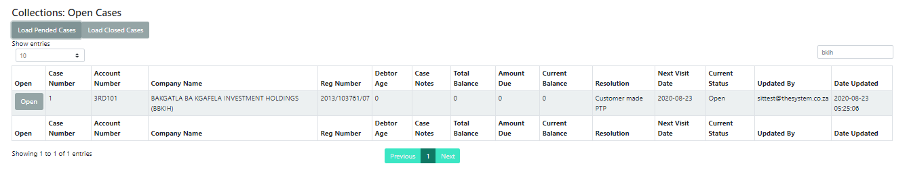

- Might be easier to read if arranged in 6 columns (instead of reading across):
  - Primary Contact
  - Representative
  - Alternate Representative
  - Other Contact
  - Other Email
  - DNC
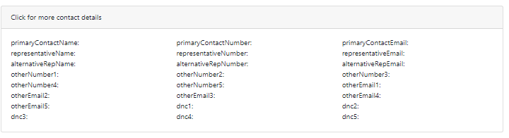

- Please remember to hyperlink contact numbers so that they initiate the call

